Your name: Anis

- Objective
- What question does this experiment answer / what hypothesis does it test?
- XGBoost is known for combining many decision trees through gradient boosting, that helps control variance on small to medium tabular datasets.
- Hypothesis: Non-linear tree-boosting model outperforms linear baselines because they can capture complex interactions between local economic indicators.
- Method
- Model name: XGBRegressor
- Key hyperparameters / settings:
PARAM_DIST = {
  - 'n_estimators' : [100, 200, 300, 500, 700, 1000],
  - 'max_depth' : [2, 3, 4, 5, 6, 7],
  - 'learning_rate' : [0.005, 0.01, 0.02, 0.05, 0.1],
  - 'subsample' : [0.5, 0.6, 0.7, 0.8, 0.9, 1.0],
  - 'colsample_bytree': [0.5, 0.6, 0.7, 0.8, 0.9, 1.0],
  - 'min_child_weight': [1, 3, 5, 7, 10, 15],
  - 'reg_alpha' : [0, 0.01, 0.05, 0.1, 0.5, 1, 2],
  - 'reg_lambda' : [0.5, 1, 1.5, 2, 3, 5],
  - 'gamma' : [0, 0.1, 0.2, 0.5, 1],
- Evaluation approach:
  - Pre-defined train/test split
  - Metrics: MAPE, MAE, RMSE, R²
  - Predictions generated for 2025 GVA per worker using the trained model
  - Log-transformation applied to stabilise variance in the target variable
- Please provide 1-2 papers related to your experiment
- Paper’s name: Forecasting sustainable development indicators using XGBoost: evidence from Brazil, Canada, China and India (2005–2023)
- Paper’s Bib: doi: {10.47556/J.WJEMSD.21.4.2025.4}
- Paper’s name: Hyperparameters Optimization in XGBoost Model for Rainfall Estimation: A Case Study in Pontianak City
  - Paper’s Bib:
@article{yasper2023hyperparameters,
  - title={Hyperparameters optimization in XGBoost model for rainfall estimation: A case study in Pontianak City},
  - author={Yasper, Auriwan and Handoko, Djati and Putra, Maulana and Aliwarga, Harry Kasuma and Rosid, Mohammad Syamsu Rosid},
  - journal={Jurnal Penelitian Pendidikan IPA},
  - volume={9},
  - number={9},
  - pages={7113--7121},
  - year={2023}
  - }

4. Results — facts only, no interpretation
- Metric values (paste ):
- 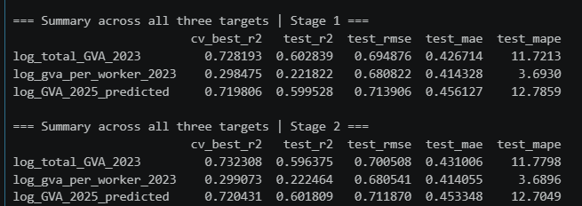
- Key figures/charts (embed or link):
5. Discussion — your judgement
- What does this result show?
- -> XGBoost performs weakly on GVA per worker, meaning per worker productivity measure is harder to predict from these indicators.
- How does it compare to the literature / the previous experiment?
- -> The papers reports tree methods outperforming linear regression on socio-economic indicators prediction.
- Anomalies / surprises:
- -> the CV R2 sists higher than the test R2 for the two stronger targets, total GVA for 2023 and predicted GVA 2025, which shows a generalization gap consistent with overfitting. However, the log_gva_per_worker_2023 has the lowest R2 but lowest MAPE showing the smallest percentage errors.
6. Reflection
- Planned approach vs. what was actually done:
- -> using the baseline XGBoost regression, however it didn’t get tp 0.6+ R2 hence hypertuning is done with stage 1 as randomizedsearch and stage 2 as gridsearchcv based on best model from stage 1
- Limitations / uncertainties:
- -> no linear baseline yet, so the central hypothesis is yet untested
- Next steps:
- -> apply regularization with slight changes on min_child_weight/gamma/reg_lambda etc.

